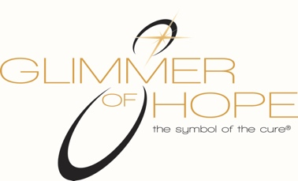

If you would like to make a donation in someone's honor or memory, please print and fill out this form and return it to: A Glimmer of Hope / P.O. Box 908 / Wexford, PA 15090 or you may fax it to 724-935-9576. You may also email the form at info@symbolofthecure.com or you may call 800-454-6746 we will gladly acknowledge your gift with a card sent to the person or family in whose honor/memory the donation was made. We thank you for your generosity and commitment to finding the cure.
Your Information
Name: ___________________________________________________________
Address: _________________________________________________________
State: ___________________________________
Zip: _________________
Email Address: ____________________________________________________
Credit Card #: _____________________________ Exp. Date: ___________

Acknowledgment Information Person to be honored or memorialized:
Name: _____________________________________________
Name of person to be acknowledged _____________________________________
Address: ________________________________________________________
State: ___________________________________
Zip: ________________
Email Address: _____________________________________________

